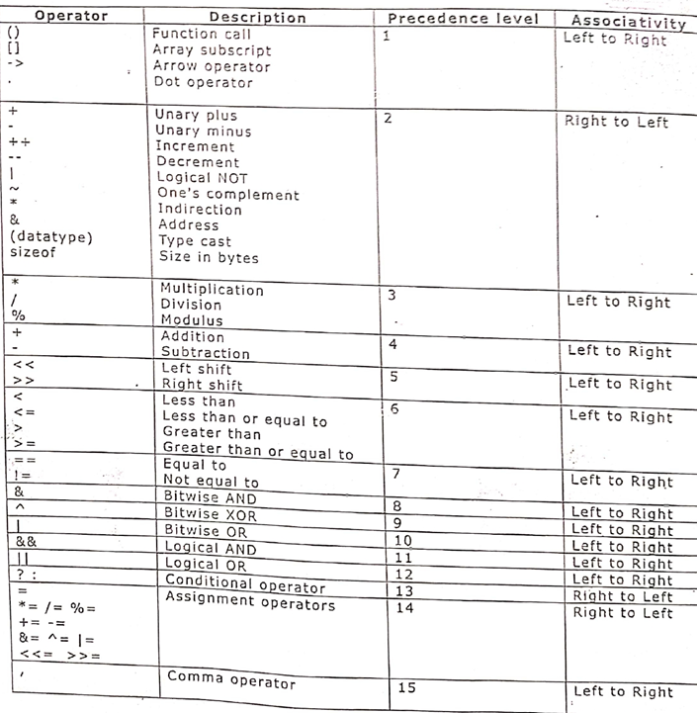

1. #include<stdio.h>
int main( )
{
unsigned char a;
a = 0xFF + 1;
printf("%u\n", a);
}=====***=====
2. #include<stdio.h>
int main()
{
int x=10, y=20, z=5, i;
i =x<y<z;
printf("%d\n", i);
}=====***=====
3. #include<stdio.h>
int main()
{
unsigned int x=022,y=0x22, z=022;
printf("%d",x+y+z);
}=====***=====
4. #include<stdio.h>
int main( )
{
printf("%d\n", 1<<4);
printf("%d\n", 68<<4);
printf("%d\n", 68>>4);
printf("%d\n", -68<<4);
printf("%d\n", -68<<4);
printf("%d\n", -35 >>2);
printf("%x\n", 1<<10);
printf("%x\n", 0xFF<<4);
printf("%o\n", 034<<2);
}
=====***=====
5. #include<stdio.h>
int main()
{
int i=8;
printf("%d",i+i*i/i-i);
}=====***=====

6. #include<stdio.h>
int main()
{
int i=15,j=20,k=25,c;
c=i+j*k-j/k+j%k;
printf("%d",c);
}=====***=====

7. #include<stdio.h>
int main()
{
int i=5,j=1,k=6,l=2;
l=i*l+j-k;
printf("%d",l);
}=====***=====
8 #include<stdio.h>
int main()
{
int i=4,j=2,k=5,l=10,m=10,n=5;
l=i-j%k*l/m+n;
printf("%d",l);
}=====***=====
9. #include<stdio.h>
int main()
{
int i=97,j=98,k=48,l=50;
printf("%d",i<j>=k!=l);
}=====***=====
10. #include<stdio.h>
int main()
{
int i;
i=12>=12<=12==12>2;
printf("%d",i);
}=====***=====
11 #include<stdio.h>
int main()
{
int i=3,j=5,k=9,L;
L=i/j||j>=k^j&i;
printf("%d\n",L);
}
=====***=====
12. #include<stdio.h>
int main()
{
int a = 10, b = 11;
a ^= b ^= a ^= b;
printf(" %d %d" , a,b);
}=====***=====
13. #include<stdio.h>
int main()
{
int a=10,b=15;
a=a+b;
b=a-b;
a=a-b;
printf("%d %d",a,b);
}=====***=====
14. #include<stdio.h>
int main()
{
int a=10,b=15;
a=a*b;
b=a/b;
a=a/b;
printf("%d %d",a,b);
}=====***=====
15. #include<stdio.h>
int main()
{
int a=10,b=15;
int t;
t=a;
a=b;
b=t;
printf("%d %d",a,b);
}=====***=====
16. #include<stdio.h>
int main()
{
printf("%d\n", 1<<4>>4);
printf("%d\n", 1<<31>>30);
}=====***=====
17. #include<stdio.h>
int main()
{
int i=4,j=8;
i=i|j&j|i;
printf("%d",i);
}=====***=====
19. #include<stdio.h>
int main()
{
int i=10,j=5;
i=i|j&&j^i;
printf("%d",i);
}=====***=====
20 #include<stdio.h>
int main()
{
int a=-3,b=-5,c=-3,d=-1;
a=a>b+3<c<d;
printf("%d",a);
}=====***=====
21. #include<stdio.h>
int main()
{
int a=-3;
a=-a-a+!a;
printf("%d",a);
}=====***=====
22. #include<stdio.h>
int main()
{
int a=2,b=1,c,d;
c=a<b;
d=(a>b)&&(c<b);
printf("%d %d",c,d);
}=====***=====
23. #include<stdio.h>
int main()
{
int a=9,b=15,c=16,d=12,e,f;
e=!(a<b||b<c);
f=(a>b)?a-b:b-a;
printf("e=%d f=%d",e,f);
}=====***=====
24. #include<stdio.h>
int main()
{
int a=5;
a=6;
a=a+5*a;
printf("%d",a);
}=====***=====
25. #include<stdio.h>
int main()
{
int a=5,b=5;
printf("%d %d\n",++a,b--);
printf("%d %d\n",a,b);
printf("%d %d\n",++a,b++);
printf("%d %d\n",a,b);
}=====***=====
26. #include<stdio.h>
int main()
{
int a=4,b=8,c=3,d=9,z;
z=a++ + ++b * c-- - --d;
printf("a=%d b=%d c=%d d=%d z=%d",a,b,c,d,z);
}=====***=====
27. #include<stdio.h>
int main()
{
int a=14,b,c;
a=a%5;
b=a/3;
c=a/5%3;
printf("a=%d b=%d c=%d",a,b,c);
}=====***=====
28. #include<stdio.h>
int main()
{
int a=15,b=13,c=16,x,y;
x=a-3%2+c*2/4%2+b/4;
y=a=b+5-b+9/3;
printf("x=%d y=%d a=%d",x,y,a);
}=====***=====
29. #include<stdio.h>
int main()
{
int x,y,z,k=10;
k+=(x=5,y=x+2,z=x+y);
printf("x=%d, y=%d, z=%d, k=%d",x,y,z,k);
}=====***=====
30. #include<stdio.h>
int main()
{
float b;
b=15/2;
printf("%f\n",b);
b=(float)15/2;
printf("%f",b);
}=====***=====
31. #include<stdio.h>
int main()
{
int a=9;
char ch='A';
a=a+ch+23;
printf("%d %c %d %c",ch,ch,a,a);
}=====***=====
32. #include<stdio.h>
int main()
{
int a,b,c,d;
a=b=c=d=4;
a*=b+1;
c+=d*=3;
printf("a=%d c=%d",a,c);
}=====***=====
33. #include<stdio.h>
int main()
{
int a=5,b=6;
printf("%d\n",a=b);
printf("%d\n",a==b);
printf("%d %d\n",a,b);
}=====***=====
34. #include<stdio.h>
int main()
{
int a=3,b=4,c=3,d=4,x,y;
x=(a=5)&&(b=7);
y=(c=5)||(d=8);
printf("a=%d ,b=%d ,c=%d ,d=%d ,x=%d ,y=%d\n",a,b,c,d,x,y);
x=(a==6)&&(b=9);
y=(c==6)||(d=10);
printf("a=%d ,b=%d ,c=%d ,d=%d ,x=%d ,y=%d\n",a,b,c,d,x,y);
}=====***=====
35. #include<stdio.h>
int main()
{
int a=8,b=4,c=2,d=1,e=5,f=20;
int z;
z=a+b-(c+d)*3%e+f/9;
printf("%d",z);
}=====***=====
36. #include<stdio.h>
int main()
{
int a=17,b=5,c=6,d=3,e=5;
int z;
z=a%6-b/2+(c*d-5)/e;
printf("%d",z);
}=====***=====
37. #include<stdio.h>
int main()
{
int a=4,b=5,c=6,d=3,e=5,f=10;
int z;
z=a*b-c/d<e+f;
printf("%d",z);
}=====***=====

